[DATABASE TECHNOLOGY](https://www.kth.se/social/course/DD1368/) DD1368 | 6.0 CREDITS

HOMEWORK -2-

***Name: Doren Calliku***

***Group: 8***

*Homework MUST be handed in via Canvas ONLY and in the correct assignment folder, in one file representing the entire homework.*

[*https://kth.instructure.com/courses/4608/assignments/19914*](https://kth.instructure.com/courses/4608/assignments/19914)

**Homework exercise:**

Study the Northshore Hospital case study file available on Canvas

1. Identify primary keys and foreign keys for the entire case study.
2. For the Wards section only, identify all entity types, attributes, relationship types and their degrees in the following case.
3. For the Wards section only, identify the main relationship types and specify the multiplicity for each relationship. State any assumptions you make about the data.
4. Produce some sample tables for these relations that observe the relational integrity rules. Suggest some general constraints that would be appropriate for this schema.

*My homework includes the extra queries to gain a grade.*

# Extra queries:

1. Explain the concept of database schema and discuss the three types of schema in a database.
2. Discuss the differences between the candidate keys and the primary key of a relation.
3. Explain what is meant by a foreign key. How do foreign keys of relations relate to candidate keys? Give examples to illustrate your answer.

A) Identify primary keys and foreign keys for the entire case study.

Primary keys are given in **Bold** and the foreign keys are given in *Italics,* and in Underline are candidate keys.

*Note: We use the extension number for the ward and the outpatient clinic because they are of the same form and there can be used the same ID for later implementation, or if we use the subclass design(suggestible).*

**Ward** = ( **ward_extNumber** , ward_no )

**Outpatient Clinic** = ( **outClinic_extNumber,** )

*Note: We use the staff number even for the following because they are of the same form and there can be used the same ID for later implementation, or if we use the subclass design(suggestible).*

**Staff Member** = (**staff_number**, staff_insurance , *staff_wardAllocation*)

**Medical Doctor = (staff_number,** staff_insurance **)**

**Personnel Officer = (staff_number,** staff_insurance **)**

**Change Nurse = (staff_number,** staff_insurance **)**

*Note: We use the patient number even for the following because they are of the same form and there can be used the same ID for later implementation, or if we use the subclass design(suggestible).*

**Patient** = ( ***patient_no***, *patient_telephone*) *// These are in italics because they can be connected to the waiting list.*

**Outpatient** = (**outpatient_no**, outpatient_telephone )

**Inpatient** = ( **inpatient_no**, inpatient_telephone, *inpatient_wardRequired*)

**Supplier** = ( **supplier_number**, supplier_address, supplier_email,supplier_telephone, supplier_faxNumber)

*Note: We use the itemNo even for the following because they are of the same form and there can be used the same ID for later implementation, or if we use the subclass design(suggestible).*

**Supply** = ( **supply_itemNo** , supply_name)

**Drug** = ( **drug_itemNo** , drug_name )

**Medication Prescription** = ( **prescription_number** , *prescription_drugNo, prescription_name*)

**Requisition Form = ( requisition_number,** *requisition_staff ,**requisition_wardNo, requisition_drugNumber*)

**Waiting List** = ( **waitingList_patientNo**)

*Note: This is a weak entity as it has no id, still, we can assume it contains the list of resource supplies from the drugs, and the list of the staff ids, and also the beds’ numbers.*

**Resource** = ( *resource_staff, resource_beds, resource_supplies*)

B) For the Wards section only, identify all entity types, attributes, relationship types and their degrees in the following case.

C) For the Wards section only, identify the main relationship types and specify the multiplicity for each relationship. State any assumptions you make about the data.

An entity is an abstract object of some sort, and a collection of similar entities forms an entity set. Entity typebeing the collection of entities having common attributes, then the wards section includes wards only.

**Attributes** being the properties describing the entities, we have the following attributes to the wards section: ward_budget, ward_no, ward_name , ward_location , ward_beds, ward_extNumber.

**Relationship types and degrees:** Relationship types used are the 1-to-many and many-to-many. The relationships degrees are ternary as the relations are connected in groups of three. The multiplicity which is a broader definition than the cardinality is included in parenthesis.

This are the relationships that include the Ward section.

Ward (1...*) - has – (0...*) Inpatient ( type: many-to-many,

degree: ternary ( Staff Member included))

Ward (1...*) - has – (1...*) Staff Member ( type: many-to-many,

degree: ternary ( Inpatient included))

Change Nurse (1) – manages – (17) Ward ( type: 1-to-many,

degree: ternary (Staff Member included))

Change Nurse (1) – manages – (1...*) Staff Member( type: 1-to-many,

degree: ternary (Ward included))

*Note:* In order to have a simplified model to produce the database the *Bed* relation is included in the ward as an compound attribute. **Medical Doctor** and the **Personnel Officer** are not related to the definition of the *Ward*, only the **Change Nurse** is the one dealing with the **Staff Members**. On the same hand, the *Supplies, the Drugs, Medications, Requisition form* and the *Waiting List* are directly related to the **Staff Members** and the **Inpatients** (and **Medical Doctor, Personnel Officer**), so that they will not be managed by the *Ward* relation, and will not be connected to it.

*Note:* ***Bold*** *are the relations that include people, and the* Italics *are the ones that are related to objects or similar concepts.*

D) Produce some sample tables for these relations that observe the relational integrity rules. Suggest some general constraints that would be appropriate for this schema.

Assumption: Relational integrity is different from referential integrity.

In order for the tables to be consistent there are four types of integrity constraints.

1. Domain integrity is related to the definition of the usage of the properties of the attributes. These can be the data type, length size, if null value is allowed and if the value is unique or not.

2. Entity integrity is related to the primary keys which cannot be null.

3. Referential integrity is used to maintained a consistent relationship between two tables and it should follow some rules related to changing a primary key,adding a non-existing foreign key, deleting a primary key.

4. Foreign key integrity is an automated response to deleting a primary key in a table which is a foreign key in another table.

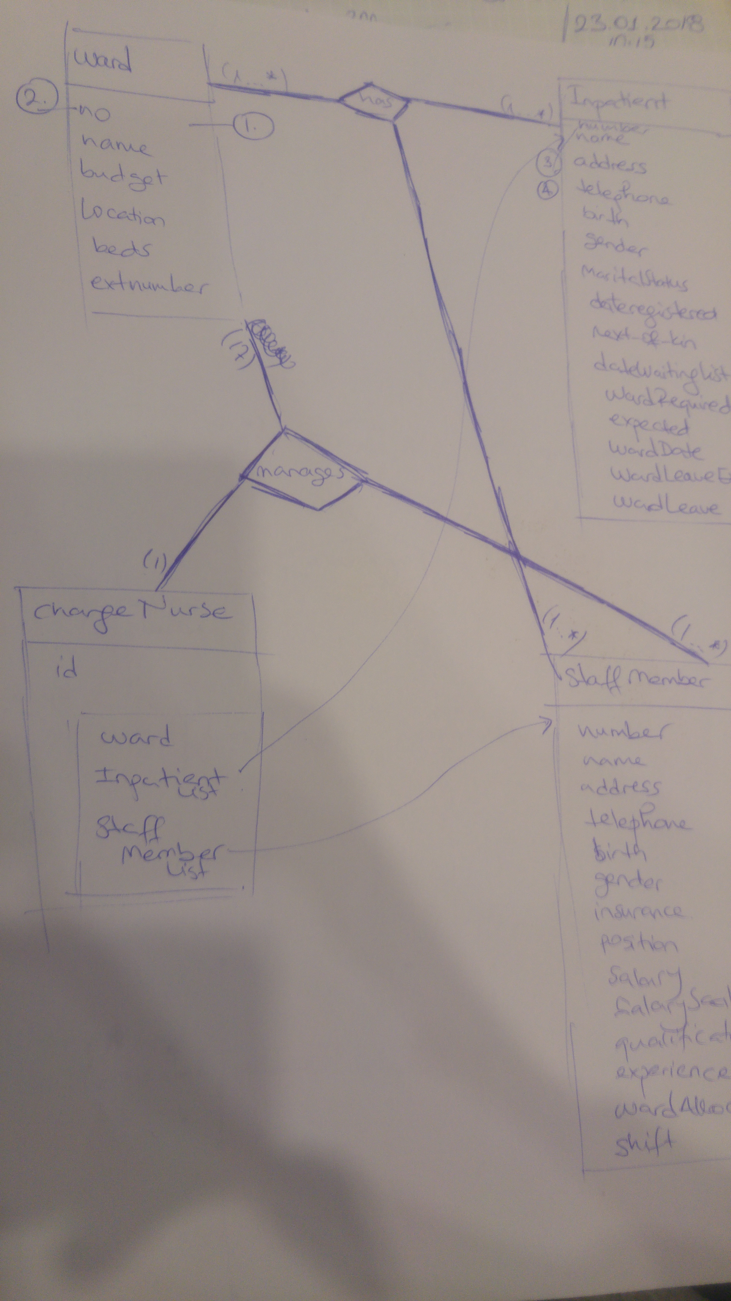

EXTRA QUERIES

A)Explain the concept of database schema and discuss the three types of schema in a database.

The design of the database is defined by the schemas. In order to explain different perspectives of the database we see it from different perspectives: physical, logical and view schema. The first one tries to picture the distribution of the data in the physical database. The logical database is the one trying to explain the relationship between relations and the types and multiplicity of the database. The last one describes the interaction with the user.

B) Discuss the differences between the candidate keys and the primary key of a relation.

In order to uniquely identify a relation in a database we need a primary key which should be used to define the differences between entries(rows). This should contain a unique value for each row. We choose the primary key from the candidate keys. What happens is that some time there are several columns or interaction of columns which can form a primary key. These columns or interaction of columns are called candidate keys because they can replace the other candidates in being primary keys and the relation(table) would work well.

C)Explain what is meant by a foreign key. How do foreign keys of relations relate to candidate keys? Give examples to illustrate your answer.

The foreign key is a column (attribute) in a table which is used as a primary key in another table(relation). Foreign keys of relations are not necessarily related to the candidate keys, but they foreign keys can be candidate keys for the table.

EX1: Lab Queue No is a candidate key and a foreign key for the table 1.

|  |  |  |
| --- | --- | --- |
| Student ID | Name | Lab Queue No |
| 1 | A | 3 |
| 2 | B | 1 |
| 3 | C | 2 |

|  |  |
| --- | --- |
| Lab Queue No | TA no |
| 1 | 1 |
| 2 | 1 |
| 3 | 2 |